Exp 1:
Implement and demonstrate the FIND-S algorithm for finding the most specific hypothesis based on a given set of training data samples.
Code:
import pandas as pd
# Step 1: Load dataset
data = pd.read_csv("/content/PlayTennis.csv")
print("Dataset Preview:\n")
print(data.head())
# Step 2: Separate features and target
X = data.iloc[:, :-1].values # outlook, temp, humidity, windy
y = data.iloc[:, -1].values # play (yes / no)
# Step 3: Initialize hypothesis with FIRST POSITIVE example
hypothesis = None
for i in range(len(y)):
if y[i].lower() == "yes":
hypothesis = X[i].copy()
break

print("\nInitial Hypothesis (First Positive Example):")
print(hypothesis)

# Step 4: Apply FIND-S algorithm
for i in range(len(X)):
if y[i].lower() == "yes": # ONLY positive examples
for j in range(len(hypothesis)):
if X[i][j] != hypothesis[j]:
hypothesis[j] = "?"
print(f"After training example {i+1}: {hypothesis}")

# Step 5: Final hypothesis
print("\nFinal Most Specific Hypothesis:")
print(hypothesis)
output:
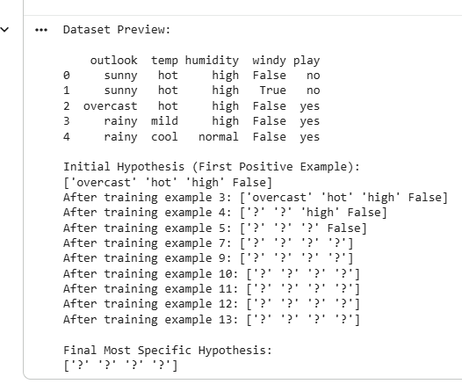
Exp 2 :
For a given set of training data examples stored in a .CSV file, implement and demonstrate the Candidate-Elimination algorithm in python to output a description of the set of all hypotheses consistent with the training examples
Code :
import pandas as pd
# Step 1: Load CSV dataset
data = pd.read_csv("/content/PlayTennis.csv")
print("Dataset Preview:\n")
print(data)
# Step 2: Use ALL examples
X = data.iloc[:, :-1].values # outlook, temp, humidity, windy
y = data.iloc[:, -1].values # play (yes / no)
num_attr = X.shape[1]
# Step 3: Extract attribute domains
domains = []
for i in range(num_attr):
domains.append(list(set(X[:, i])))
# Step 4: Initialize S and G
S = None
G = [['?'] * num_attr]
# Helper functions
def covers(h, x):
"""Check if hypothesis h covers instance x"""
return all(h[i] == '?' or h[i] == x[i] for i in range(len(h)))
def more_general_or_equal(h1, h2):
"""Check if h1 is more general than or equal to h2"""
return all(h1[i] == '?' or h1[i] == h2[i] for i in range(len(h1)))
# Step 5: Candidate-Elimination on ALL examples
for i in range(len(X)):
instance = X[i]
label = y[i].lower()
# ---------- POSITIVE EXAMPLE ----------
if label == 'yes':
if S is None:
S = list(instance)
else:
for j in range(num_attr):
if S[j] != instance[j]:
S[j] = '?'
# Remove inconsistent hypotheses from G
G = [g for g in G if covers(g, instance)]

# ---------- NEGATIVE EXAMPLE ----------
else:
if S is None:
continue

new_G = []
for g in G:
if covers(g, instance):
for j in range(num_attr):
if g[j] == '?':
for value in domains[j]:
if value != instance[j]:
new_h = g.copy()
new_h[j] = value
if more_general_or_equal(new_h, S):
new_G.append(new_h)
else:
new_G.append(g)
G = new_G
print(f"\nAfter example {i+1} ({label}):")
print("S =", S)
print("G =", G)
# Step 6: Final Version Space
print("Final Version Space (All Examples)")
print("Specific Boundary (S):", S)
print("General Boundary (G):", G)
output:
Dataset Preview:
outlook temp humidity windy play
0 sunny hot high False no
1 sunny hot high True no
2 overcast hot high False yes
3 rainy mild high False yes
4 rainy cool normal False yes
5 rainy cool normal True no
6 overcast cool normal True yes
7 sunny mild high False no
8 sunny cool normal False yes
9 rainy mild normal False yes
10 sunny mild normal True yes
11 overcast mild high True yes
12 overcast hot normal False yes
13 rainy mild high True no

After example 3 (yes):
S = ['overcast', 'hot', 'high', False]
G = [['?', '?', '?', '?']]
After example 4 (yes):
S = ['?', '?', 'high', False]
G = [['?', '?', '?', '?']]
After example 5 (yes):
S = ['?', '?', '?', False]
G = [['?', '?', '?', '?']]
After example 6 (no):
S = ['?', '?', '?', False]
G = [['?', '?', '?', False]]
After example 7 (yes):
S = ['?', '?', '?', '?']
G = []
After example 8 (no):
S = ['?', '?', '?', '?']
G = []
After example 9 (yes):
S = ['?', '?', '?', '?']
G = []
After example 10 (yes):
S = ['?', '?', '?', '?']
G = []
After example 11 (yes):
S = ['?', '?', '?', '?']
G = []
After example 12 (yes):
S = ['?', '?', '?', '?']
G = []
After example 13 (yes):
S = ['?', '?', '?', '?']
G = []
After example 14 (no):
S = ['?', '?', '?', '?']
G = []
Final Version Space (All Examples)
Specific Boundary (S): ['?', '?', '?', '?']
General Boundary (G): []
Exp 3:
Demonstrate the working of the decision tree based ID3 algorithm. Use an appropriate data set for building the decision tree and apply this knowledge to classify a new sample.
Code :
# Step 1: Import Libraries
import pandas as pd
from sklearn.preprocessing import LabelEncoder
from sklearn.tree import DecisionTreeClassifier, plot_tree
import matplotlib.pyplot as plt
# Step 2: Load Dataset
data = pd.read_csv("/content/play_tennis.csv")
# Drop the 'day' column (just ID)
data = data.drop('day', axis=1)
# Step 3: Encode categorical features
le_dict = {}
for col in data.columns:
le = LabelEncoder()
data[col] = le.fit_transform(data[col])
le_dict[col] = le
# Separate features and target
X = data.iloc[:, :-1]
y = data.iloc[:, -1]
# Step 4: Train Decision Tree using ID3 (entropy)
clf = DecisionTreeClassifier(criterion='entropy')
clf.fit(X, y)
# Step 5: Display the tree (graphically)
plt.figure(figsize=(20,10))
plot_tree(clf,
feature_names=X.columns,
class_names=le_dict['play'].classes_,
filled=True,
rounded=True,
fontsize=12)
plt.title("Decision Tree (ID3) - Play Tennis Dataset")
plt.show()
# Step 6: Classify a new sample
new_sample = pd.DataFrame([["Sunny", "Cool", "High", "Weak"]],
columns=['outlook','temp','humidity','wind'])
# Encode new sample
for col in new_sample.columns:
le = le_dict[col]
new_sample[col] = le.transform(new_sample[col])
# Predict
prediction = clf.predict(new_sample)
predicted_class = le_dict['play'].inverse_transform(prediction)
print("\nNew Sample Prediction:")
print(new_sample)
print("Predicted Class:", predicted_class[0])
Output :
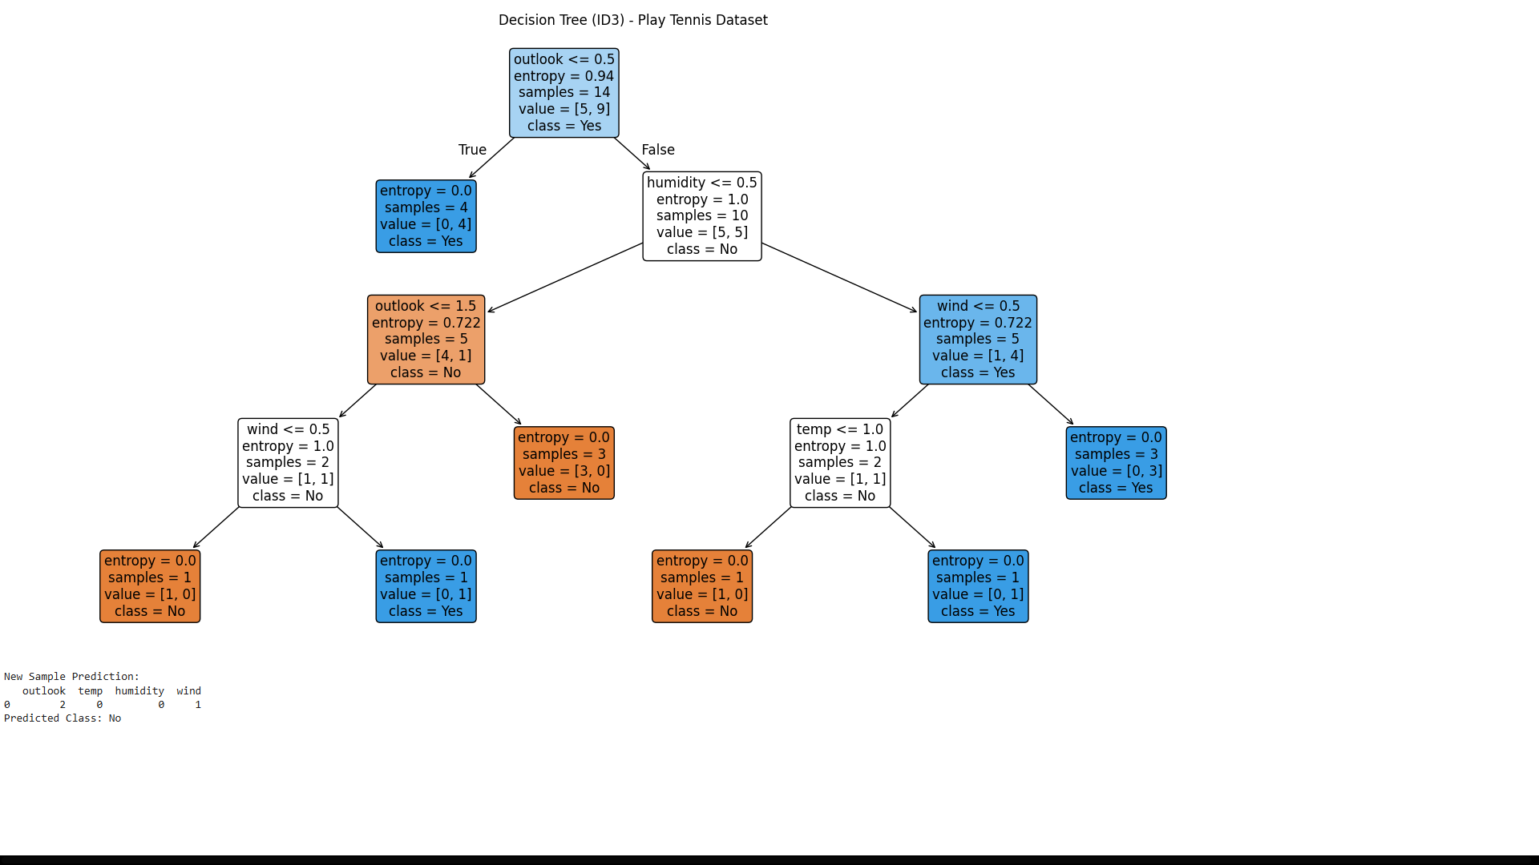
Exp 4:
Build an Artificial Neural Network by implementing the Backpropagation algorithm and test the same using appropriate data sets.
Code:
import numpy as np
import pandas as pd
from sklearn.model_selection import train_test_split
from sklearn.preprocessing import StandardScaler
# Load dataset
data = pd.read_csv("/content/diabetes.csv")
# Separate features and target
X = data.iloc[:, :-1].values
y = data.iloc[:, -1].values
# Normalize features
scaler = StandardScaler()
X = scaler.fit_transform(X)
# Train-test split
X_train, X_test, y_train, y_test = train_test_split(X, y, test_size=0.2, random_state=42)
# Convert target to one-hot encoding (binary classification)
y_train = y_train.reshape(-1, 1)
y_test = y_test.reshape(-1, 1)
# ANN Implementation (Backpropagation)
class NeuralNetwork:
def __init__(self, input_size, hidden_size, output_size, learning_rate=0.01, epochs=5000):
self.input_size = input_size
self.hidden_size = hidden_size
self.output_size = output_size
self.learning_rate = learning_rate
self.epochs = epochs

# Initialize weights
self.W1 = np.random.randn(self.input_size, self.hidden_size)
self.b1 = np.zeros((1, self.hidden_size))
self.W2 = np.random.randn(self.hidden_size, self.output_size)
self.b2 = np.zeros((1, self.output_size))

def sigmoid(self, z):
return 1 / (1 + np.exp(-z))

def sigmoid_derivative(self, z):
return z * (1 – z)
def train(self, X, y):
for epoch in range(self.epochs):
# Forward pass
z1 = np.dot(X, self.W1) + self.b1
a1 = self.sigmoid(z1)
z2 = np.dot(a1, self.W2) + self.b2
a2 = self.sigmoid(z2)
# Compute error
error = y - a2
# Backpropagation
d_a2 = error * self.sigmoid_derivative(a2)
d_W2 = np.dot(a1.T, d_a2)
d_b2 = np.sum(d_a2, axis=0, keepdims=True)
d_a1 = np.dot(d_a2, self.W2.T) * self.sigmoid_derivative(a1)
d_W1 = np.dot(X.T, d_a1)
d_b1 = np.sum(d_a1, axis=0, keepdims=True)

# Update weights
self.W1 += self.learning_rate * d_W1
self.b1 += self.learning_rate * d_b1
self.W2 += self.learning_rate * d_W2
self.b2 += self.learning_rate * d_b2
# Print loss occasionally
if epoch % 1000 == 0:
loss = np.mean(np.square(error))
print(f"Epoch {epoch}, Loss: {loss:.4f}")
def predict(self, X):
z1 = np.dot(X, self.W1) + self.b1
a1 = self.sigmoid(z1)
z2 = np.dot(a1, self.W2) + self.b2
a2 = self.sigmoid(z2)
return (a2 > 0.5).astype(int)
# Train and Test ANN
# Define network: input = 8 features, hidden = 10 neurons, output = 1 (binary classification)
nn = NeuralNetwork(input_size=X_train.shape[1], hidden_size=10, output_size=1, learning_rate=0.01, epochs=5000)
# Train
nn.train(X_train, y_train)
# Test
y_pred = nn.predict(X_test)
print(f"\nTest Accuracy: {accuracy * 100:.2f}%")
Output :
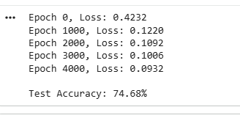
Exp 5:
Write a program for Implementation of K-Nearest Neighbours (K-NN) in Python
Code :
import pandas as pd
from sklearn.model_selection import train_test_split
from sklearn.preprocessing import StandardScaler
from sklearn.neighbors import KNeighborsClassifier
from sklearn.metrics import accuracy_score, classification_report
# Load dataset (example: diabetes.csv)
# Replace with your dataset path
data = pd.read_csv("/content/diabetes.csv")
# Separate features and target
X = data.iloc[:, :-1].values
y = data.iloc[:, -1].values
# Preprocessing
scaler = StandardScaler()
X = scaler.fit_transform(X)
# Train-test split
X_train, X_test, y_train, y_test = train_test_split(
X, y, test_size=0.2, random_state=42
)
# KNN Classifier
k = 5 # number of neighbors
knn = KNeighborsClassifier(n_neighbors=k)
# Train
knn.fit(X_train, y_train)
# Predict
y_pred = knn.predict(X_test)
# Evaluation
print(f"Accuracy: {accuracy_score(y_test, y_pred) * 100:.2f}%")
print("\nClassification Report:\n", classification_report(y_test, y_pred))
Output :
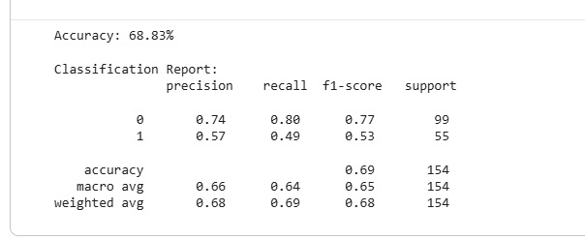
Exp 6:
Write a program to implement Naïve Bayes algorithm in python and to display the results using confusion matrix and accuracy.
Code:
import pandas as pd
from sklearn.model_selection import train_test_split
from sklearn.preprocessing import StandardScaler
from sklearn.naive_bayes import GaussianNB
from sklearn.metrics import confusion_matrix, classification_report, accuracy_score
# --- Load Dataset ---
df = pd.read_csv('/content/diabetes.csv')
# Features and labels
X = df.iloc[:, :-1].values # all columns except last
y = df.iloc[:, -1].values # last column (Outcome: 0 or 1)
# --- Standardize features (important for continuous variables) ---
scaler = StandardScaler()
X = scaler.fit_transform(X)
# --- Train-test split ---
X_train, X_test, y_train, y_test = train_test_split(X, y, test_size=0.2, random_state=42)
# --- Initialize and train Gaussian Naive Bayes ---
model = GaussianNB()
model.fit(X_train, y_train)
# --- Make predictions ---
y_pred = model.predict(X_test)
# --- Accuracy ---
accuracy = accuracy_score(y_test, y_pred)
print(f"Accuracy: {accuracy*100:.2f}%")
# --- Confusion Matrix ---
cm = confusion_matrix(y_test, y_pred)
print("\nConfusion Matrix:")
print(cm)
Output:
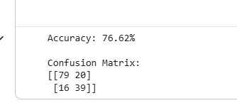
Exp 7 :
Write a program to implement Logistic Regression (LR) algorithm in python
Code:
import pandas as pd
from sklearn.model_selection import train_test_split
from sklearn.preprocessing import StandardScaler
from sklearn.linear_model import LogisticRegression
from sklearn.metrics import confusion_matrix, classification_report, accuracy_score

# --- Load Dataset ---
df = pd.read_csv('/content/diabetes.csv')
# Features and labels
X = df.iloc[:, :-1].values # all columns except last
y = df.iloc[:, -1].values # last column (Outcome: 0 or 1)
# --- Standardize features ---
scaler = StandardScaler()
X = scaler.fit_transform(X)
# --- Train-test split ---
X_train, X_test, y_train, y_test = train_test_split(X, y, test_size=0.2, random_state=42)
# --- Logistic Regression Model ---
model = LogisticRegression()
model.fit(X_train, y_train)
# --- Predictions ---
y_pred = model.predict(X_test)
# --- Accuracy ---
accuracy = accuracy_score(y_test, y_pred)
print(f"Accuracy: {accuracy*100:.2f}%")
# --- Confusion Matrix ---
cm = confusion_matrix(y_test, y_pred)
print("\nConfusion Matrix:")
print(cm)
# --- Classification Report ---
cr = classification_report(y_test, y_pred)
print("\nClassification Report:")
print(cr)
Output:
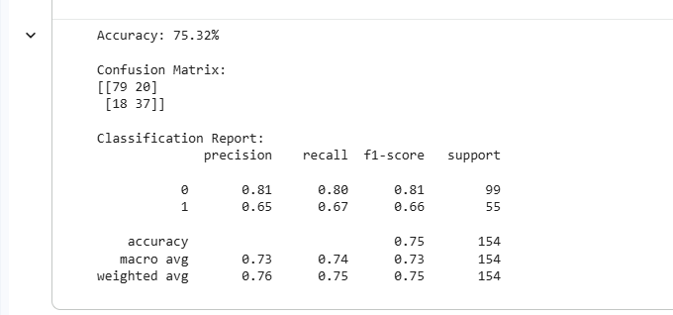
Exp 8 :
Write a program to implement Linear Regression (LR) algorithm in python
Code :
import pandas as pd
import matplotlib.pyplot as plt
from sklearn.model_selection import train_test_split
from sklearn.linear_model import LinearRegression
from sklearn.preprocessing import OneHotEncoder
from sklearn.compose import ColumnTransformer
from sklearn.metrics import mean_squared_error, r2_score
# Load dataset
data = pd.read_csv("/content/insurance.csv")
# Separate features and target
X = data.drop("charges", axis=1)
y = data["charges"]
# Preprocessing (handle categorical variables)
categorical_features = ["sex", "smoker", "region"]
# One-hot encode categorical features
ct = ColumnTransformer(
transformers=[("encoder", OneHotEncoder(drop="first"), categorical_features)],
remainder="passthrough"
)
X = ct.fit_transform(X)
# Train-test split
X_train, X_test, y_train, y_test = train_test_split(
X, y, test_size=0.2, random_state=42
)
# Linear Regression Model
lr = LinearRegression()
lr.fit(X_train, y_train)

# Predict
y_pred = lr.predict(X_test)
# Evaluation
print("Mean Squared Error:", mean_squared_error(y_test, y_pred))
print("R2 Score:", r2_score(y_test, y_pred))
# Visualization: Actual vs Predicted
plt.scatter(y_test, y_pred, color="blue", alpha=0.6, label="Predicted vs Actual")
plt.plot([y_test.min(), y_test.max()],
[y_test.min(), y_test.max()],
color="red", linewidth=2, label="Perfect Prediction")
plt.xlabel("Actual Charges")
plt.ylabel("Predicted Charges")
plt.title("Linear Regression: Actual vs Predicted Charges")
plt.legend()
plt.show()
Output :
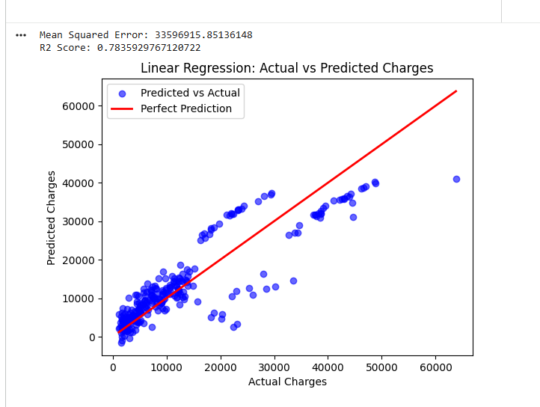
Exp 9 :
Compare Linear and Polynomial Regression using Python
Code :
import pandas as pd
import matplotlib.pyplot as plt
from sklearn.model_selection import train_test_split
from sklearn.linear_model import LinearRegression
from sklearn.preprocessing import PolynomialFeatures, OneHotEncoder
from sklearn.compose import ColumnTransformer
from sklearn.metrics import mean_squared_error, r2_score
# Load dataset
data = pd.read_csv("/content/insurance.csv")
print(data.head())
# Separate features and target
X = data.drop("charges", axis=1)
y = data["charges"]
# Handle categorical variables
categorical_features = ["sex", "smoker", "region"]
ct = ColumnTransformer(
transformers=[("encoder", OneHotEncoder(drop="first"), categorical_features)],
remainder="passthrough"
)
X = ct.fit_transform(X)
# Train-test split
X_train, X_test, y_train, y_test = train_test_split(
X, y, test_size=0.2, random_state=42
)
# Linear Regression
lin_reg = LinearRegression()
lin_reg.fit(X_train, y_train)
y_pred_lin = lin_reg.predict(X_test)
print("Linear Regression MSE:", mean_squared_error(y_test, y_pred_lin))
print("Linear Regression R2:", r2_score(y_test, y_pred_lin))
# Polynomial Regression (degree=2)
poly = PolynomialFeatures(degree=2)
X_train_poly = poly.fit_transform(X_train)
X_test_poly = poly.transform(X_test)
poly_reg = LinearRegression()
poly_reg.fit(X_train_poly, y_train)
y_pred_poly = poly_reg.predict(X_test_poly)
print("Polynomial Regression MSE:", mean_squared_error(y_test, y_pred_poly))
print("Polynomial Regression R2:", r2_score(y_test, y_pred_poly))
# Visualization: Actual vs Predicted
plt.figure(figsize=(10,5))
plt.scatter(y_test, y_pred_lin, color="blue", alpha=0.6, label="Linear Regression")
plt.scatter(y_test, y_pred_poly, color="green", alpha=0.6, label="Polynomial Regression (deg=2)")
plt.plot([y_test.min(), y_test.max()],
[y_test.min(), y_test.max()],
color="red", linewidth=2, label="Perfect Prediction")
plt.xlabel("Actual Charges")
plt.ylabel("Predicted Charges")
plt.title("Linear vs Polynomial Regression on Insurance Dataset")
plt.legend()
plt.show()
output :
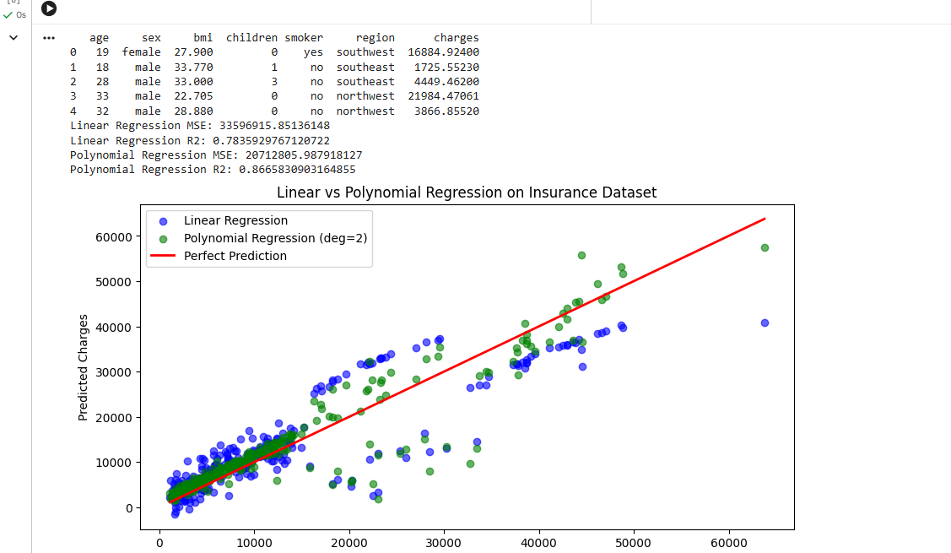
Exp 10:
Write a Python Program to Implement Expectation & Maximization Algorithm
Code :
import pandas as pd
import numpy as np
import matplotlib.pyplot as plt
from sklearn.mixture import GaussianMixture

# Step 1: Load Kaggle Insurance dataset

data = pd.read_csv("/content/insurance.csv")
X = data[["bmi", "charges"]].values

# Step 2: Apply EM via Gaussian Mixture Model
gmm = GaussianMixture(n_components=2, random_state=42)
gmm.fit(X)
labels = gmm.predict(X)

# Step 3: Print learned parameters
print("Means:", gmm.means_)
print("Covariances:", gmm.covariances_)
print("Weights:", gmm.weights_)

# Step 4: Visualization
plt.figure(figsize=(10,6))
plt.scatter(X[:,0], X[:,1], c=labels, cmap="viridis", s=40, alpha=0.7)
plt.xlabel("BMI")
plt.ylabel("Charges")
plt.title("EM Clustering on Insurance Dataset (BMI vs Charges)")
plt.colorbar(label="Cluster")
plt.show()
Output:
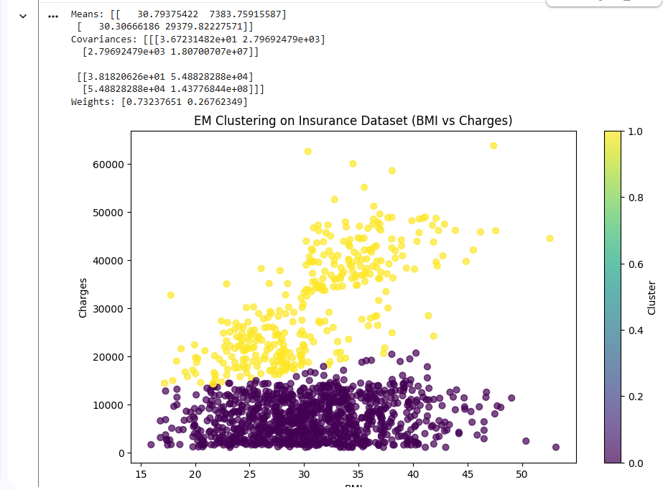

11. Write a program for the task of Credit Score Classification
CODE:
import pandas as pd
import numpy as np
from sklearn.model_selection import train_test_split
from sklearn.ensemble import RandomForestClassifier
from sklearn.preprocessing import LabelEncoder
from sklearn.metrics import accuracy_score

# Load dataset
data = pd.read_csv("CREDITSCORE.csv")

# Drop rows with missing values
data = data.dropna()

# Encode categorical columns
le = LabelEncoder()
data["Credit_Mix"] = le.fit_transform(data["Credit_Mix"])
data["Credit_Score"] = le.fit_transform(data["Credit_Score"])

# Select features and target
X = data[[
"Annual_Income",
"Monthly_Inhand_Salary",
"Num_Bank_Accounts",
"Num_Credit_Card",
"Interest_Rate",
"Num_of_Loan",
"Delay_from_due_date",
"Num_of_Delayed_Payment",
"Credit_Mix",
"Outstanding_Debt",
"Credit_History_Age",
"Monthly_Balance"
]]

y = data["Credit_Score"]

# Train-test split
X_train, X_test, y_train, y_test = train_test_split(
X, y, test_size=0.33, random_state=42
)

# Train model
model = RandomForestClassifier(n_estimators=100, random_state=42)
model.fit(X_train, y_train)
# Accuracy
y_pred = model.predict(X_test)
print("Model Accuracy:", accuracy_score(y_test, y_pred)*100)
# ---------------- Prediction Section ----------------
print("\nEnter details for Credit Score Prediction:")
a = float(input("Annual Income: "))
b = float(input("Monthly Inhand Salary: "))
c = float(input("Number of Bank Accounts: "))
d = float(input("Number of Credit Cards: "))
e = float(input("Interest Rate: "))
f = float(input("Number of Loans: "))
g = float(input("Delay from due date (days): "))
h = float(input("Number of Delayed Payments: "))
i = int(input("Credit Mix (Bad=0, Standard=1, Good=2): "))
j = float(input("Outstanding Debt: "))
k = float(input("Credit History Age (months): "))
l = float(input("Monthly Balance: "))
features = np.array([[a, b, c, d, e, f, g, h, i, j, k, l]])
prediction = model.predict(features)
# Decode output
credit_score_map = {0: "Good", 1: "Poor", 2: "Standard"}
print("\nPredicted Credit Score:", credit_score_map[prediction[0]])

OUTPUT:
Model Accuracy: 80.19872249822569
Enter details for Credit Score Prediction:
Annual Income: 60000
Monthly Inhand Salary: 30000
Number of Bank Accounts: 2
Number of Credit Cards: 2
Interest Rate: 0.2
Number of Loans: 1
Delay from due date (days): 20
Number of Delayed Payments: 2
Credit Mix (Bad=0, Standard=1, Good=2): 1
Outstanding Debt: 50000
Credit History Age (months): 120
Monthly Balance: 8000

Predicted Credit Score: Standard

12.Implement Iris Flower Classification using KNN
CODE:
import pandas as pd
import matplotlib.pyplot as plt
import numpy as np
iris = pd.read_csv("IRIS.csv")
print(iris.head())
print()
print(iris.describe())
print("Target Labels", iris["species"].unique())
import plotly.io as io
import plotly.express as px
fig = px.scatter(iris, x="sepal_width", y="sepal_length", color="species")
fig.show()
x = iris.drop("species", axis=1)
y = iris["species"]
from sklearn.model_selection import train_test_split
x_train, x_test, y_train, y_test = train_test_split(x, y,test_size=0.2,random_state=0)
from sklearn.neighbors import KNeighborsClassifier
knn = KNeighborsClassifier(n_neighbors=1)
knn.fit(x_train, y_train)
x_new = np.array([[6, 2.9, 1, 0.2]])
prediction = knn.predict(x_new)
print("Prediction: {}".format(prediction))

OUTPUT:
sepal_length sepal_width petal_length petal_width species
0 5.1 3.5 1.4 0.2 Iris-setosa
1 4.9 3.0 1.4 0.2 Iris-setosa
2 4.7 3.2 1.3 0.2 Iris-setosa
3 4.6 3.1 1.5 0.2 Iris-setosa
4 5.0 3.6 1.4 0.2 Iris-setosa

sepal_length sepal_width petal_length petal_width
count 150.000000 150.000000 150.000000 150.000000
mean 5.843333 3.054000 3.758667 1.198667
std 0.828066 0.433594 1.764420 0.763161
min 4.300000 2.000000 1.000000 0.100000
25% 5.100000 2.800000 1.600000 0.300000
50% 5.800000 3.000000 4.350000 1.300000
75% 6.400000 3.300000 5.100000 1.800000
max 7.900000 4.400000 6.900000 2.500000
Target Labels ['Iris-setosa' 'Iris-versicolor' 'Iris-virginica']
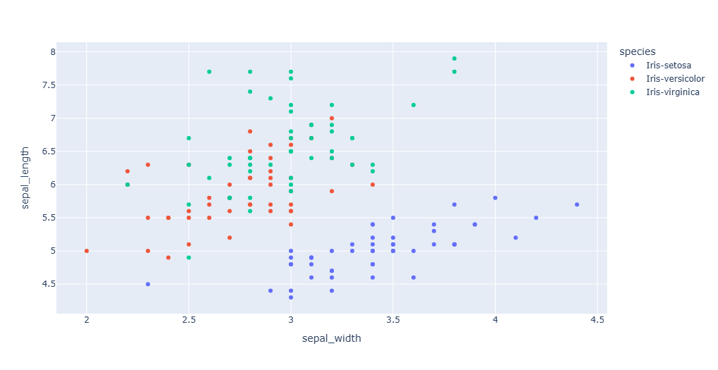

X does not have valid feature names, but KNeighborsClassifier was fitted with feature names
13 Implement the Car Price Prediction Model using Python
CODE:
import numpy as np
import pandas as pd
import matplotlib.pyplot as plt
import seaborn as sns

from sklearn.model_selection import train_test_split
from sklearn.tree import DecisionTreeRegressor
from sklearn.metrics import mean_absolute_error

# Importing the dataset
data = pd.read_csv("CarPrice.csv")

# Data Exploration
print(data.head())
print("Shape:", data.shape)
print("Missing values:\n", data.isnull().sum())
print(data.info())
print(data.describe())
print("Unique car names:", data['CarName'].unique())

# Analyzing correlations with only numeric data
numeric_data = data.select_dtypes(include='number')
print(numeric_data.corr())

plt.figure(figsize=(20, 15))
sns.heatmap(numeric_data.corr(), cmap="coolwarm", annot=True)
plt.title("Correlation Heatmap")
plt.show()

# Training a Car Price Prediction Model
predict = "price"
features = ["symboling", "wheelbase", "carlength",
"carwidth", "carheight", "curbweight",
"enginesize", "boreratio", "stroke",
"compressionratio", "horsepower", "peakrpm",
"citympg", "highwaympg"]

# Extracting features and target
x = data[features].values
y = data[predict].values

# Splitting data
xtrain, xtest, ytrain, ytest = train_test_split(x, y, test_size=0.2, random_state=42)

# Decision Tree Regressor
model = DecisionTreeRegressor()
model.fit(xtrain, ytrain)

# Predictions
predictions = model.predict(xtest)

# Evaluation
mae = mean_absolute_error(ytest, predictions)
score = model.score(xtest, ytest)

print(f"\nModel Score (R²): {score:.4f}")
print(f"Mean Absolute Error: {mae:.2f}")

OUTPUT:
car_ID symboling CarName fueltype aspiration doornumber \
0 1 3 alfa-romero giulia gas std two
1 2 3 alfa-romero stelvio gas std two
2 3 1 alfa-romero Quadrifoglio gas std two
3 4 2 audi 100 ls gas std four
4 5 2 audi 100ls gas std four

carbody drivewheel enginelocation wheelbase ... enginesize \
0 convertible rwd front 88.6 ... 130
1 convertible rwd front 88.6 ... 130
2 hatchback rwd front 94.5 ... 152
3 sedan fwd front 99.8 ... 109
4 sedan 4wd front 99.4 ... 136

fuelsystem boreratio stroke compressionratio horsepower peakrpm citympg \
0 mpfi 3.47 2.68 9.0 111 5000 21
1 mpfi 3.47 2.68 9.0 111 5000 21
2 mpfi 2.68 3.47 9.0 154 5000 19
3 mpfi 3.19 3.40 10.0 102 5500 24
4 mpfi 3.19 3.40 8.0 115 5500 18

highwaympg price
0 27 13495.0
1 27 16500.0
2 26 16500.0
3 30 13950.0
4 22 17450.0

[5 rows x 26 columns]
Shape: (205, 26)
Missing values:
car_ID 0
symboling 0
CarName 0
fueltype 0
aspiration 0
doornumber 0
carbody 0
drivewheel 0
enginelocation 0
wheelbase 0
carlength 0
carwidth 0
carheight 0
curbweight 0
enginetype 0
cylindernumber 0
enginesize 0
fuelsystem 0
boreratio 0
stroke 0
compressionratio 0
horsepower 0
peakrpm 0
citympg 0
highwaympg 0
price 0
dtype: int64
<class 'pandas.core.frame.DataFrame'>
RangeIndex: 205 entries, 0 to 204
Data columns (total 26 columns):
# Column Non-Null Count Dtype
--- ------ -------------- -----
0 car_ID 205 non-null int64
1 symboling 205 non-null int64
2 CarName 205 non-null object
3 fueltype 205 non-null object
4 aspiration 205 non-null object
5 doornumber 205 non-null object
6 carbody 205 non-null object
7 drivewheel 205 non-null object
8 enginelocation 205 non-null object
9 wheelbase 205 non-null float64
10 carlength 205 non-null float64
11 carwidth 205 non-null float64
12 carheight 205 non-null float64
13 curbweight 205 non-null int64
14 enginetype 205 non-null object
15 cylindernumber 205 non-null object
16 enginesize 205 non-null int64
17 fuelsystem 205 non-null object
18 boreratio 205 non-null float64
19 stroke 205 non-null float64
20 compressionratio 205 non-null float64
21 horsepower 205 non-null int64
22 peakrpm 205 non-null int64
23 citympg 205 non-null int64
24 highwaympg 205 non-null int64
25 price 205 non-null float64
dtypes: float64(8), int64(8), object(10)
memory usage: 41.8+ KB
None
car_ID symboling wheelbase carlength carwidth carheight \
count 205.000000 205.000000 205.000000 205.000000 205.000000 205.000000
mean 103.000000 0.834146 98.756585 174.049268 65.907805 53.724878
std 59.322565 1.245307 6.021776 12.337289 2.145204 2.443522
min 1.000000 -2.000000 86.600000 141.100000 60.300000 47.800000
25% 52.000000 0.000000 94.500000 166.300000 64.100000 52.000000
50% 103.000000 1.000000 97.000000 173.200000 65.500000 54.100000
75% 154.000000 2.000000 102.400000 183.100000 66.900000 55.500000
max 205.000000 3.000000 120.900000 208.100000 72.300000 59.800000

curbweight enginesize boreratio stroke compressionratio \
count 205.000000 205.000000 205.000000 205.000000 205.000000
mean 2555.565854 126.907317 3.329756 3.255415 10.142537
std 520.680204 41.642693 0.270844 0.313597 3.972040
min 1488.000000 61.000000 2.540000 2.070000 7.000000
25% 2145.000000 97.000000 3.150000 3.110000 8.600000
50% 2414.000000 120.000000 3.310000 3.290000 9.000000
75% 2935.000000 141.000000 3.580000 3.410000 9.400000
max 4066.000000 326.000000 3.940000 4.170000 23.000000

horsepower peakrpm citympg highwaympg price
count 205.000000 205.000000 205.000000 205.000000 205.000000
mean 104.117073 5125.121951 25.219512 30.751220 13276.710571
std 39.544167 476.985643 6.542142 6.886443 7988.852332
min 48.000000 4150.000000 13.000000 16.000000 5118.000000
25% 70.000000 4800.000000 19.000000 25.000000 7788.000000
50% 95.000000 5200.000000 24.000000 30.000000 10295.000000
75% 116.000000 5500.000000 30.000000 34.000000 16503.000000
max 288.000000 6600.000000 49.000000 54.000000 45400.000000
Unique car names: ['alfa-romero giulia' 'alfa-romero stelvio' 'alfa-romero Quadrifoglio'
'audi 100 ls' 'audi 100ls' 'audi fox' 'audi 5000' 'audi 4000'
'audi 5000s (diesel)' 'bmw 320i' 'bmw x1' 'bmw x3' 'bmw z4' 'bmw x4'
'bmw x5' 'chevrolet impala' 'chevrolet monte carlo' 'chevrolet vega 2300'
'dodge rampage' 'dodge challenger se' 'dodge d200' 'dodge monaco (sw)'
'dodge colt hardtop' 'dodge colt (sw)' 'dodge coronet custom'
'dodge dart custom' 'dodge coronet custom (sw)' 'honda civic'
'honda civic cvcc' 'honda accord cvcc' 'honda accord lx'
'honda civic 1500 gl' 'honda accord' 'honda civic 1300' 'honda prelude'
'honda civic (auto)' 'isuzu MU-X' 'isuzu D-Max ' 'isuzu D-Max V-Cross'
'jaguar xj' 'jaguar xf' 'jaguar xk' 'maxda rx3' 'maxda glc deluxe'
'mazda rx2 coupe' 'mazda rx-4' 'mazda glc deluxe' 'mazda 626' 'mazda glc'
'mazda rx-7 gs' 'mazda glc 4' 'mazda glc custom l' 'mazda glc custom'
'buick electra 225 custom' 'buick century luxus (sw)' 'buick century'
'buick skyhawk' 'buick opel isuzu deluxe' 'buick skylark'
'buick century special' 'buick regal sport coupe (turbo)'
'mercury cougar' 'mitsubishi mirage' 'mitsubishi lancer'
'mitsubishi outlander' 'mitsubishi g4' 'mitsubishi mirage g4'
'mitsubishi montero' 'mitsubishi pajero' 'Nissan versa' 'nissan gt-r'
'nissan rogue' 'nissan latio' 'nissan titan' 'nissan leaf' 'nissan juke'
'nissan note' 'nissan clipper' 'nissan nv200' 'nissan dayz' 'nissan fuga'
'nissan otti' 'nissan teana' 'nissan kicks' 'peugeot 504' 'peugeot 304'
'peugeot 504 (sw)' 'peugeot 604sl' 'peugeot 505s turbo diesel'
'plymouth fury iii' 'plymouth cricket' 'plymouth satellite custom (sw)'
'plymouth fury gran sedan' 'plymouth valiant' 'plymouth duster'
'porsche macan' 'porcshce panamera' 'porsche cayenne' 'porsche boxter'
'renault 12tl' 'renault 5 gtl' 'saab 99e' 'saab 99le' 'saab 99gle'
'subaru' 'subaru dl' 'subaru brz' 'subaru baja' 'subaru r1' 'subaru r2'
'subaru trezia' 'subaru tribeca' 'toyota corona mark ii' 'toyota corona'
'toyota corolla 1200' 'toyota corona hardtop' 'toyota corolla 1600 (sw)'
'toyota carina' 'toyota mark ii' 'toyota corolla'
'toyota corolla liftback' 'toyota celica gt liftback'
'toyota corolla tercel' 'toyota corona liftback' 'toyota starlet'
'toyota tercel' 'toyota cressida' 'toyota celica gt' 'toyouta tercel'
'vokswagen rabbit' 'volkswagen 1131 deluxe sedan' 'volkswagen model 111'
'volkswagen type 3' 'volkswagen 411 (sw)' 'volkswagen super beetle'
'volkswagen dasher' 'vw dasher' 'vw rabbit' 'volkswagen rabbit'
'volkswagen rabbit custom' 'volvo 145e (sw)' 'volvo 144ea' 'volvo 244dl'
'volvo 245' 'volvo 264gl' 'volvo diesel' 'volvo 246']
car_ID symboling wheelbase carlength carwidth \
car_ID 1.000000 -0.151621 0.129729 0.170636 0.052387
symboling -0.151621 1.000000 -0.531954 -0.357612 -0.232919
wheelbase 0.129729 -0.531954 1.000000 0.874587 0.795144
carlength 0.170636 -0.357612 0.874587 1.000000 0.841118
carwidth 0.052387 -0.232919 0.795144 0.841118 1.000000
carheight 0.255960 -0.541038 0.589435 0.491029 0.279210
curbweight 0.071962 -0.227691 0.776386 0.877728 0.867032
enginesize -0.033930 -0.105790 0.569329 0.683360 0.735433
boreratio 0.260064 -0.130051 0.488750 0.606454 0.559150
stroke -0.160824 -0.008735 0.160959 0.129533 0.182942
compressionratio 0.150276 -0.178515 0.249786 0.158414 0.181129
horsepower -0.015006 0.070873 0.353294 0.552623 0.640732
peakrpm -0.203789 0.273606 -0.360469 -0.287242 -0.220012
citympg 0.015940 -0.035823 -0.470414 -0.670909 -0.642704
highwaympg 0.011255 0.034606 -0.544082 -0.704662 -0.677218
price -0.109093 -0.079978 0.577816 0.682920 0.759325

carheight curbweight enginesize boreratio stroke \
car_ID 0.255960 0.071962 -0.033930 0.260064 -0.160824
symboling -0.541038 -0.227691 -0.105790 -0.130051 -0.008735
wheelbase 0.589435 0.776386 0.569329 0.488750 0.160959
carlength 0.491029 0.877728 0.683360 0.606454 0.129533
carwidth 0.279210 0.867032 0.735433 0.559150 0.182942
carheight 1.000000 0.295572 0.067149 0.171071 -0.055307
curbweight 0.295572 1.000000 0.850594 0.648480 0.168790
enginesize 0.067149 0.850594 1.000000 0.583774 0.203129
boreratio 0.171071 0.648480 0.583774 1.000000 -0.055909
stroke -0.055307 0.168790 0.203129 -0.055909 1.000000
compressionratio 0.261214 0.151362 0.028971 0.005197 0.186110
horsepower -0.108802 0.750739 0.809769 0.573677 0.080940
peakrpm -0.320411 -0.266243 -0.244660 -0.254976 -0.067964
citympg -0.048640 -0.757414 -0.653658 -0.584532 -0.042145
highwaympg -0.107358 -0.797465 -0.677470 -0.587012 -0.043931
price 0.119336 0.835305 0.874145 0.553173 0.079443

compressionratio horsepower peakrpm citympg \
car_ID 0.150276 -0.015006 -0.203789 0.015940
symboling -0.178515 0.070873 0.273606 -0.035823
wheelbase 0.249786 0.353294 -0.360469 -0.470414
carlength 0.158414 0.552623 -0.287242 -0.670909
carwidth 0.181129 0.640732 -0.220012 -0.642704
carheight 0.261214 -0.108802 -0.320411 -0.048640
curbweight 0.151362 0.750739 -0.266243 -0.757414
enginesize 0.028971 0.809769 -0.244660 -0.653658
boreratio 0.005197 0.573677 -0.254976 -0.584532
stroke 0.186110 0.080940 -0.067964 -0.042145
compressionratio 1.000000 -0.204326 -0.435741 0.324701
horsepower -0.204326 1.000000 0.131073 -0.801456
peakrpm -0.435741 0.131073 1.000000 -0.113544
citympg 0.324701 -0.801456 -0.113544 1.000000
highwaympg 0.265201 -0.770544 -0.054275 0.971337
price 0.067984 0.808139 -0.085267 -0.685751

highwaympg price
car_ID 0.011255 -0.109093
symboling 0.034606 -0.079978
wheelbase -0.544082 0.577816
carlength -0.704662 0.682920
carwidth -0.677218 0.759325
carheight -0.107358 0.119336
curbweight -0.797465 0.835305
enginesize -0.677470 0.874145
boreratio -0.587012 0.553173
stroke -0.043931 0.079443
compressionratio 0.265201 0.067984
horsepower -0.770544 0.808139
peakrpm -0.054275 -0.085267
citympg 0.971337 -0.685751
highwaympg 1.000000 -0.697599
price -0.697599 1.000000
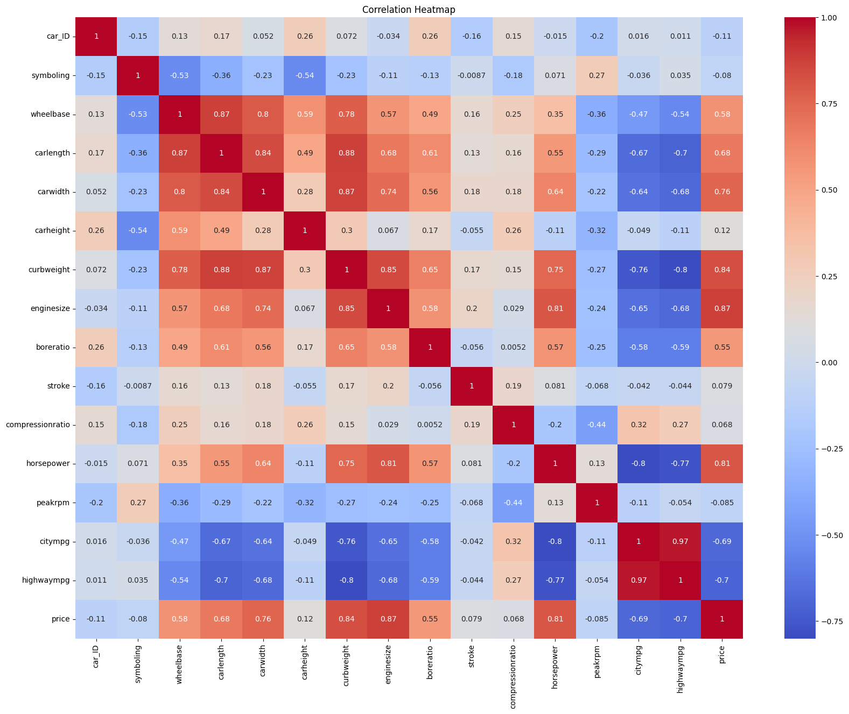
Model Score (R²): 0.9042
Mean Absolute Error: 1828.75

14 Implement House price Prediction using appropriate machine learning algorithm
CODE:
import pandas as pd
import matplotlib.pyplot as plt
import seaborn as sns
from sklearn.preprocessing import OneHotEncoder
from sklearn.model_selection import train_test_split
from sklearn.metrics import mean_absolute_percentage_error
from sklearn import svm
from sklearn.linear_model import LinearRegression

# Load dataset
dataset = pd.read_csv("HousePricePrediction.csv")

print(dataset.head())
print("Shape:", dataset.shape)

# Identify column types
object_cols = dataset.select_dtypes(include='object').columns.tolist()
num_cols = dataset.select_dtypes(include='int').columns.tolist()
float_cols = dataset.select_dtypes(include='float').columns.tolist()

print("Categorical variables:", len(object_cols))
print("Integer variables:", len(num_cols))
print("Float variables:", len(float_cols))

# Correlation heatmap
numeric_data = dataset.select_dtypes(include=['number'])
plt.figure(figsize=(12, 6))
sns.heatmap(numeric_data.corr(), cmap='BrBG', annot=True)
plt.title("Correlation Heatmap")
plt.show()

# Drop ID column
dataset.drop(['Id'], axis=1, inplace=True)

# Handle missing values
dataset['SalePrice'] = dataset['SalePrice'].fillna(dataset['SalePrice'].mean())
new_dataset = dataset.dropna()

# Categorical columns
object_cols = new_dataset.select_dtypes(include='object').columns.tolist()
print("Categorical variables:", object_cols)

# One-Hot Encoding (FIXED)
OH_encoder = OneHotEncoder(sparse_output=False, handle_unknown='ignore')
OH_cols = pd.DataFrame(
OH_encoder.fit_transform(new_dataset[object_cols]),
columns=OH_encoder.get_feature_names_out(object_cols),
index=new_dataset.index
)

# Final dataset
df_final = new_dataset.drop(object_cols, axis=1)
df_final = pd.concat([df_final, OH_cols], axis=1)

# Features and target
X = df_final.drop('SalePrice', axis=1)
Y = df_final['SalePrice']

# Train-test split
X_train, X_valid, Y_train, Y_valid = train_test_split(
X, Y, test_size=0.2, random_state=0
)

# Support Vector Regression
model_SVR = svm.SVR()
model_SVR.fit(X_train, Y_train)
Y_pred_svr = model_SVR.predict(X_valid)
print("SVR MAPE:", mean_absolute_percentage_error(Y_valid, Y_pred_svr))

# Linear Regression
model_LR = LinearRegression()
model_LR.fit(X_train, Y_train)
Y_pred_lr = model_LR.predict(X_valid)
print("Linear Regression MAPE:", mean_absolute_percentage_error(Y_valid, Y_pred_lr))

OUTPUT:
Id MSSubClass MSZoning LotArea LotConfig BldgType OverallCond \
0 0 60 RL 8450 Inside 1Fam 5
1 1 20 RL 9600 FR2 1Fam 8
2 2 60 RL 11250 Inside 1Fam 5
3 3 70 RL 9550 Corner 1Fam 5
4 4 60 RL 14260 FR2 1Fam 5

YearBuilt YearRemodAdd Exterior1st BsmtFinSF2 TotalBsmtSF SalePrice
0 2003 2003 VinylSd 0.0 856.0 208500.0
1 1976 1976 MetalSd 0.0 1262.0 181500.0
2 2001 2002 VinylSd 0.0 920.0 223500.0
3 1915 1970 Wd Sdng 0.0 756.0 140000.0
4 2000 2000 VinylSd 0.0 1145.0 250000.0
Shape: (2919, 13)
Categorical variables: 4
Integer variables: 6
Float variables: 3
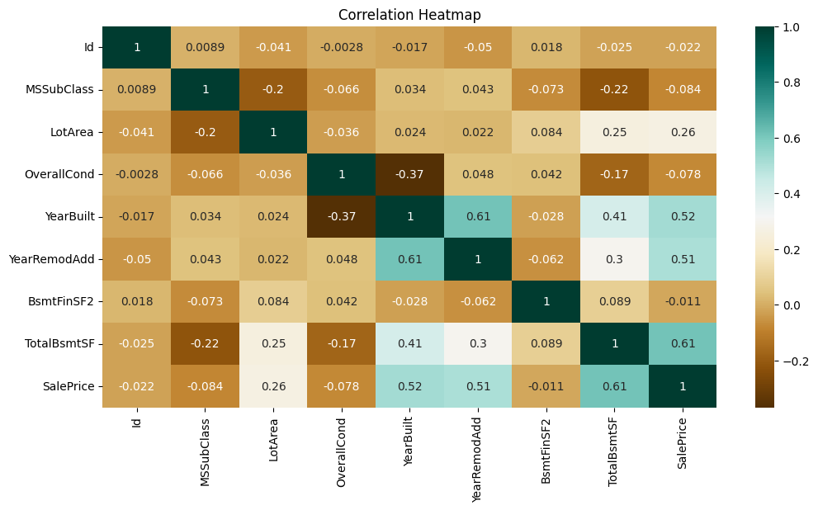
Categorical variables: ['MSZoning', 'LotConfig', 'BldgType', 'Exterior1st']
SVR MAPE: 0.1870512931870423
Linear Regression MAPE: 0.1874168384159986

15 Implement Iris Flower Classification using Naive Bayes classifier
from sklearn.naive_bayes import GaussianNB
from sklearn.naive_bayes import MultinomialNB
from sklearn import datasets
from sklearn.metrics import confusion_matrix
#Load the iris dataset
iris = datasets.load_iris()
#GaussianNB and MultinomialNB Models
gnb = GaussianNB()
mnb = MultinomialNB()
#Train both GaussianNB and MultinomialNB Models and print their confusion matrices
y_pred_gnb = gnb.fit(iris.data, iris.target).predict(iris.data)
cnf_matrix_gnb = confusion_matrix(iris.target, y_pred_gnb)
print("Confusion Matrix of GNB \n",cnf_matrix_gnb)

y_pred_mnb = mnb.fit(iris.data, iris.target).predict(iris.data)
cnf_matrix_mnb = confusion_matrix(iris.target, y_pred_mnb)
print("Confusion Matrix of MNB \n",cnf_matrix_mnb)

OUTPUT:
Confusion Matrix of GNB
[[50 0 0]
[ 0 47 3]
[ 0 3 47]]
Confusion Matrix of MNB
[[50 0 0]
[ 0 46 4]
[ 0 3 47]]
Confusion Matrix of GNB
[[50 0 0]
[ 0 47 3]
[ 0 3 47]]
Confusion Matrix of MNB
[[50 0 0]
[ 0 46 4]
[ 0 3 47]]

16 Compare different types Classification Algorithms and evaluate their performance.
CODE:
import pandas as pd
from sklearn.model_selection import train_test_split
from sklearn.tree import DecisionTreeClassifier
from sklearn.linear_model import LogisticRegression, PassiveAggressiveClassifier
from sklearn.neighbors import KNeighborsClassifier

iris = pd.read_csv("/content/IRIS-1.csv")
print(iris.head())

x = iris.drop("species", axis=1)
y = iris["species"]

x_train, x_test, y_train, y_test = train_test_split(x, y, test_size=0.2, random_state=42)

decisiontree = DecisionTreeClassifier()
logisticregression = LogisticRegression(max_iter=200)
knearestclassifier = KNeighborsClassifier()
passiveAggressive = PassiveAggressiveClassifier()

knearestclassifier.fit(x_train, y_train)
decisiontree.fit(x_train, y_train)
logisticregression.fit(x_train, y_train)
passiveAggressive.fit(x_train, y_train)

data1 = {
"Classification Algorithms": [
"KNN Classifier",
"Decision Tree Classifier",
"Logistic Regression",
"Passive Aggressive Classifier"
],
"Score": [
knearestclassifier.score(x_test, y_test),
decisiontree.score(x_test, y_test),
logisticregression.score(x_test, y_test),
passiveAggressive.score(x_test, y_test)
]
}

score_df = pd.DataFrame(data1)
print(score_df)

OUTPUT:
sepal_length sepal_width petal_length petal_width species
0 5.1 3.5 1.4 0.2 Iris-setosa
1 4.9 3.0 1.4 0.2 Iris-setosa
2 4.7 3.2 1.3 0.2 Iris-setosa
3 4.6 3.1 1.5 0.2 Iris-setosa
4 5.0 3.6 1.4 0.2 Iris-setosa

Classification Algorithms Score
0 KNN Classifier 1.000000
1 Decision Tree Classifier 1.000000
2 Logistic Regression 1.000000
3 Passive Aggressive Classifier 0.866667

17 Implement Mobile Price Prediction using appropriate machine learning algorithm
CODE:
import numpy as np
import pandas as pd
import matplotlib.pyplot as plt
import seaborn as sns

from sklearn.model_selection import train_test_split
from sklearn.preprocessing import StandardScaler
from sklearn.linear_model import LogisticRegression
from sklearn.metrics import accuracy_score, confusion_matrix

data = pd.read_csv("mobile_prices.csv")

print("Dataset Preview:\n", data.head())

plt.figure(figsize=(10, 8))
sns.heatmap(data.select_dtypes(include='number').corr(), annot=True, cmap="coolwarm", linewidths=1)
plt.title("Feature Correlation Heatmap")
plt.show()
x = data.iloc[:, :-1].values
y = data.iloc[:, -1].values
scaler = StandardScaler()
x = scaler.fit_transform(x)
x_train, x_test, y_train, y_test = train_test_split(x, y, test_size=0.20, random_state=0)
lreg = LogisticRegression(max_iter=200)
lreg.fit(x_train, y_train)
y_pred = lreg.predict(x_test)
accuracy = accuracy_score(y_test, y_pred) * 100
print("\nAccuracy of Logistic Regression Model: {:.2f}%".format(accuracy))
(unique, counts) = np.unique(y_pred, return_counts=True)
price_range = np.asarray((unique, counts)).T
print("\nPredicted Class Distribution:\n", price_range)
plt.figure(figsize=(10, 5))
plt.plot(y_test[:20], marker='o', label='Actual', linestyle='-', color='blue')
plt.plot(y_pred[:20], marker='x', label='Predicted', linestyle='--', color='red')
plt.title("Actual vs Predicted (First 20 Samples)")
plt.xlabel("Sample Index")
plt.ylabel("Price Range")
plt.legend()
plt.grid(True)
plt.show()
plt.figure(figsize=(8, 5))
sns.countplot(x=y_pred, palette="Set2")
plt.title("Predicted Price Range Distribution")
plt.xlabel("Price Range Class")
plt.ylabel("Count")
plt.show()
conf_matrix = confusion_matrix(y_test, y_pred)
plt.figure(figsize=(6, 5))
sns.heatmap(conf_matrix, annot=True, fmt="d", cmap="Blues")
plt.title("Confusion Matrix")
plt.xlabel("Predicted")
plt.ylabel("Actual")
plt.show()

OUTPUT:
Dataset Preview:
battery_power blue clock_speed dual_sim fc four_g int_memory m_dep \
0 842 0 2.2 0 1 0 7 0.6
1 1021 1 0.5 1 0 1 53 0.7
2 563 1 0.5 1 2 1 41 0.9
3 615 1 2.5 0 0 0 10 0.8
4 1821 1 1.2 0 13 1 44 0.6

mobile_wt n_cores ... px_height px_width ram sc_h sc_w talk_time \
0 188 2 ... 20 756 2549 9 7 19
1 136 3 ... 905 1988 2631 17 3 7
2 145 5 ... 1263 1716 2603 11 2 9
3 131 6 ... 1216 1786 2769 16 8 11
4 141 2 ... 1208 1212 1411 8 2 15

three_g touch_screen wifi price_range
0 0 0 1 1
1 1 1 0 2
2 1 1 0 2
3 1 0 0 2
4 1 1 0 1

[5 rows x 21 columns]
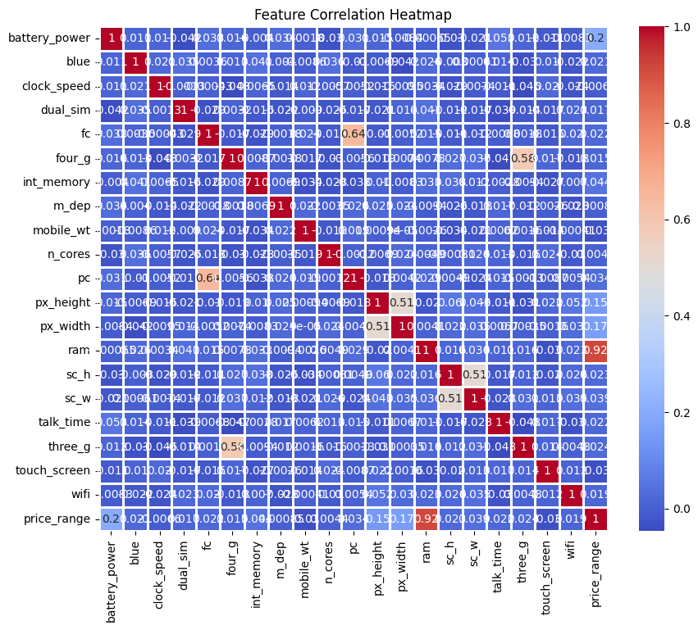
Accuracy of Logistic Regression Model: 95.50%

Predicted Class Distribution:
[[ 0 95]
[ 1 90]
[ 2 97]
[ 3 118]]
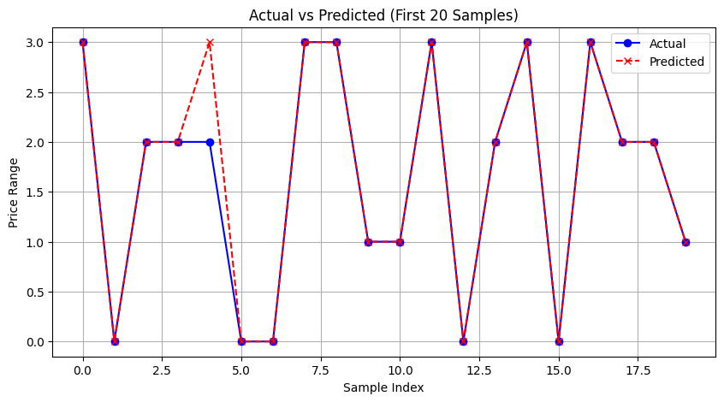
/tmp/ipython-input-3307486328.py:50: FutureWarning:

Passing `palette` without assigning `hue` is deprecated and will be removed in v0.14.0. Assign the `x` variable to `hue` and set `legend=False` for the same effect.

sns.countplot(x=y_pred, palette="Set2")
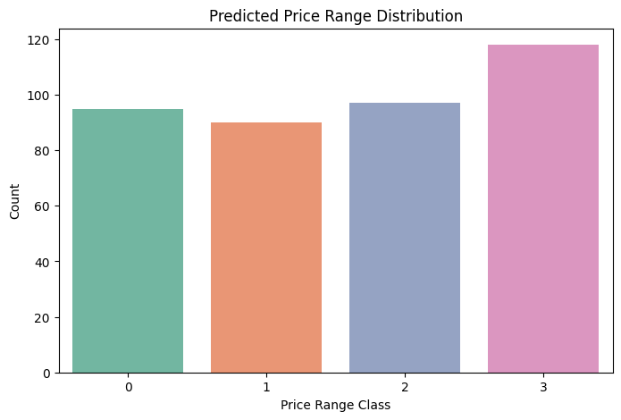

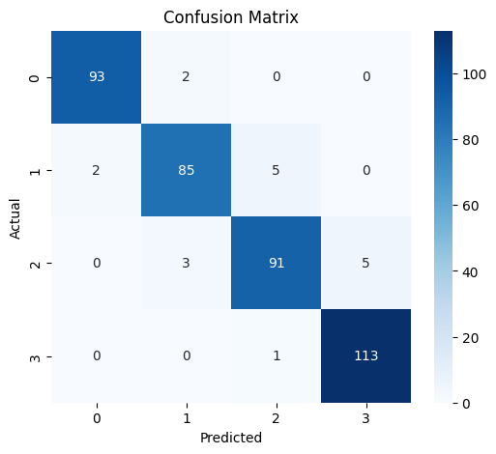
18 Implement Perceptron based IRIS classification
CODE:
from sklearn import datasets
import numpy as np
from sklearn.model_selection import train_test_split
from sklearn.linear_model import Perceptron
from sklearn.preprocessing import StandardScaler
from sklearn.metrics import accuracy_score

iris = datasets.load_iris()
X = iris.data[:, [2, 3]]
y = iris.target

X_train, X_test, y_train, y_test = train_test_split(
X, y, test_size=0.3, random_state=1, stratify=y)
sc = StandardScaler()
sc.fit(X_train)
X_train_std = sc.transform(X_train)
X_test_std = sc.transform(X_test)

ppn = Perceptron(eta0=0.1, random_state=1)
ppn.fit(X_train_std, y_train)
y_pred = ppn.predict(X_test_std)

acc = accuracy_score(y_test, y_pred) * 100
print("Accuracy: %.1f" % acc)

OUTPUT:
Accuracy: 97.8
19 Implementation of Naive Bayes classification for Bank Loan prediction
CODE:
import numpy as np
import pandas as pd

dataset = pd.read_csv("breastcancer.csv")
X = dataset.iloc[:, :-1].values
y = dataset.iloc[:, -1].values

from sklearn.model_selection import train_test_split
X_train, X_test, y_train, y_test = train_test_split(X, y, test_size = 0.25, random_state = 0)
from sklearn.preprocessing import StandardScaler
sc = StandardScaler()
X_train = sc.fit_transform(X_train)
X_test = sc.transform(X_test)

from sklearn.naive_bayes import GaussianNB
classifier = GaussianNB()
classifier.fit(X_train, y_train)
GaussianNB(priors=None, var_smoothing=1e-09)

from sklearn.metrics import confusion_matrix, accuracy_score
y_pred = classifier.predict(X_test)
cm = confusion_matrix(y_test, y_pred)
print(cm)
print("Accuracy:",accuracy_score(y_test, y_pred))

OUTPUT:
[[99 8]
[ 2 62]]
Accuracy: 0.9415204678362573

20 Implement Future Sales Prediction using a suitable machine learning algorithm
CODE:
# Import required libraries
import pandas as pd
import numpy as np
from sklearn.model_selection import train_test_split
from sklearn.linear_model import LinearRegression
import plotly.express as px
import plotly.io as pio

# Fix Plotly for Google Colab
pio.renderers.default = "colab"

# Load dataset
data = pd.read_csv("futuresale prediction.csv")

# Display dataset info
print(data.head())
print("\nMissing Values:\n", data.isnull().sum())

# Separate features and target
X = data[['TV', 'Radio', 'Newspaper']]
y = data['Sales']

# Train-test split
X_train, X_test, y_train, y_test = train_test_split(
X, y, test_size=0.2, random_state=42
)

# Train Linear Regression model
model = LinearRegression()
model.fit(X_train, y_train)

# Calculate accuracy (R² score)
accuracy = model.score(X_test, y_test) * 100
print("\nModel Accuracy: {:.1f}%".format(accuracy))

# Data visualization
fig1 = px.scatter(data, x="TV", y="Sales", size="TV",
title="TV Advertisement vs Sales")
fig1.show()

fig2 = px.scatter(data, x="Radio", y="Sales", size="Radio",
title="Radio Advertisement vs Sales")
fig2.show()

fig3 = px.scatter(data, x="Newspaper", y="Sales", size="Newspaper",
title="Newspaper Advertisement vs Sales")
fig3.show()

OUTPUT:
TV Radio Newspaper Sales
0 230.1 37.8 69.2 22.1
1 44.5 39.3 45.1 10.4
2 17.2 45.9 69.3 12.0
3 151.5 41.3 58.5 16.5
4 180.8 10.8 58.4 17.9

Missing Values:
TV 0
Radio 0
Newspaper 0
Sales 0
dtype: int64

Model Accuracy: 90.6%
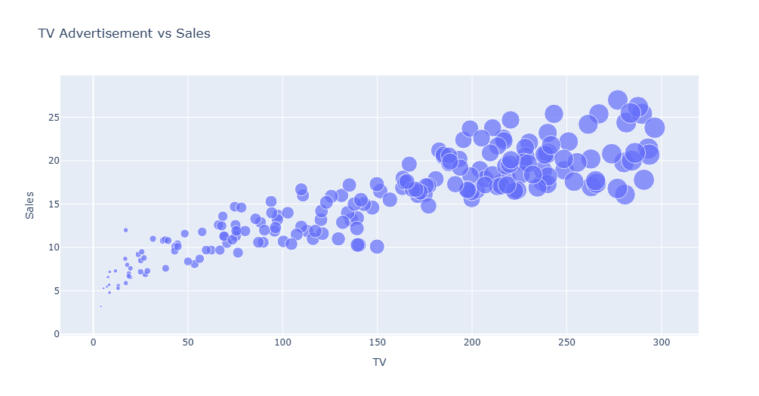
TV Advertisement vs SalesTVSales
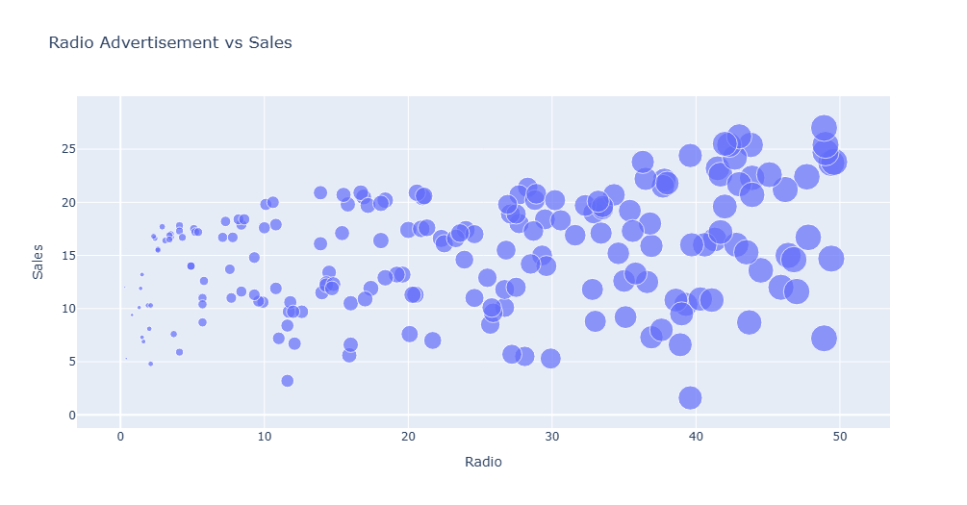
Radio Advertisement vs SalesRadioSales
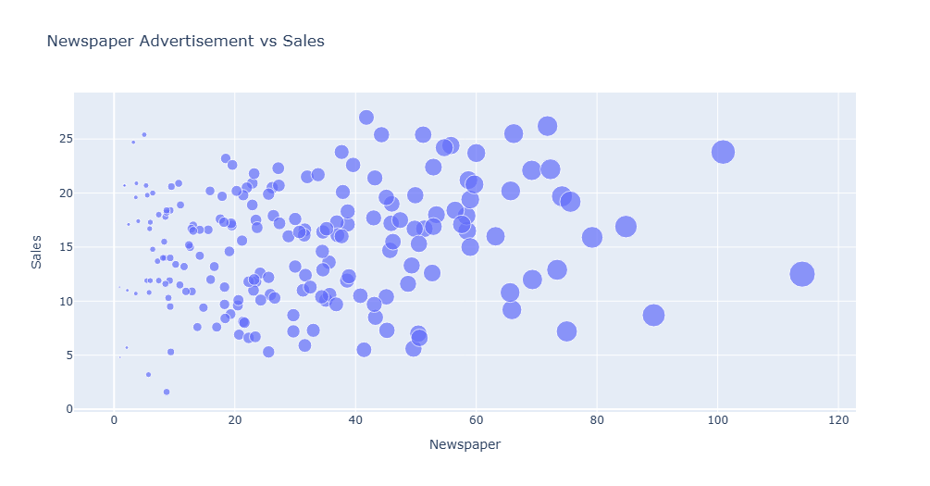
Newspaper Advertisement vs SalesNewspaperSales

